Application Server and Web Server

01. Install nginx and run nginx on port number 81.
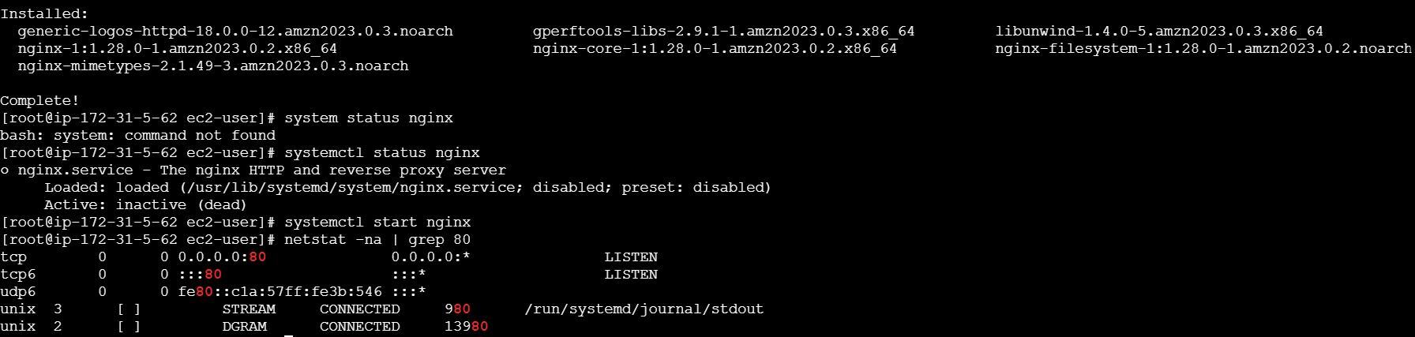
Steps:
# yum install nginx
# systemctl start nginx
# systemctl status nginx
#netstat -na | grep 80
Nginx is installed.


Steps:
Successfully running nginx on port no.81
#Deployment location -- /usr/share/nginx/html
#cd /usr/share/nginx/html
# vi index.html

02. Deploy a sample index.html file on nginx.

- 
- Steps:
- # I copied sample static website from browser
- #cd /usr/share/nginx/html
# wget copied link pasted here
# rename to index.html mv filename index.htlm

03. Install Apache and run Apache on port number 82
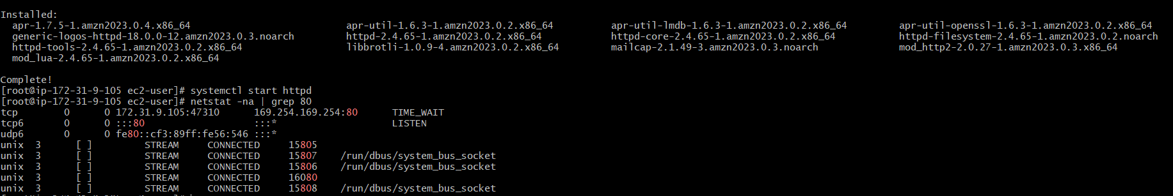
Steps :
#installed apache
yum install httpd
systemctl start httpd
netstat -na | grep 80


This is with port : 82

04. Deploy a sample index.html file on Apache.

Steps:
I have created one sample file with index.html
By using touch index.html
Then vi index.html
Inserted text : <h1> welcome to techie horizon<h1>
Checked in browser it is running.

05.Install Apache tomcat on port number 8082

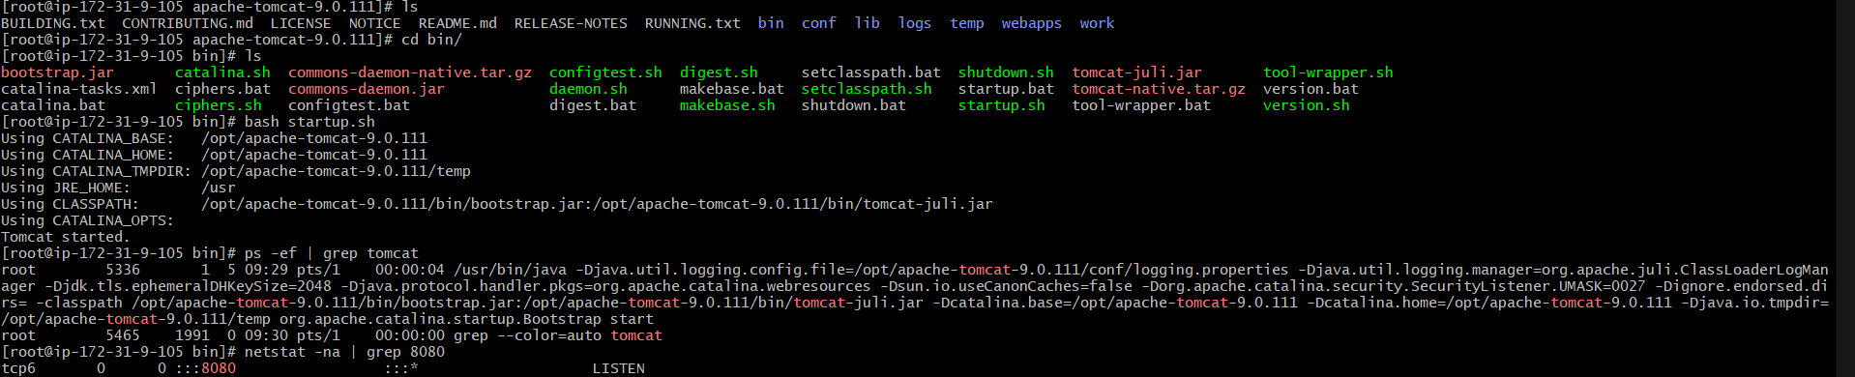
Steps :
We need to install tomcat of latest version for that
Change directory to cd opt/ ---- this is an optional directory where we can download the files.
After downloading from browser --- copy link address
wget http://.....
- To extract tar xvf apache-tomcat
- cd /apache-tomcat location
- cd bin/
ls --- to see the files
Here we see ----- startup.sh
Then use command bash startup.sh ---to start Apache tomcat
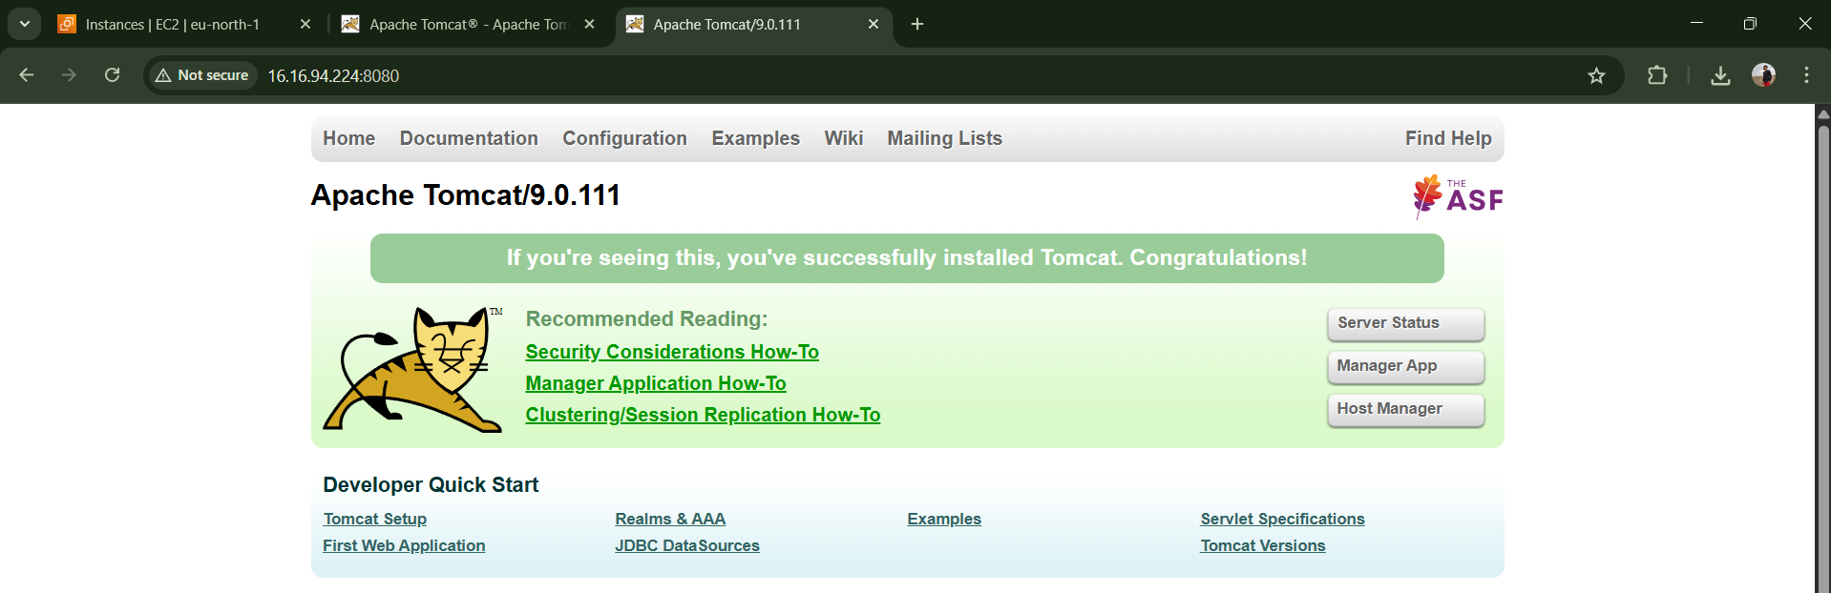

Changed to port number :8080 to 8082
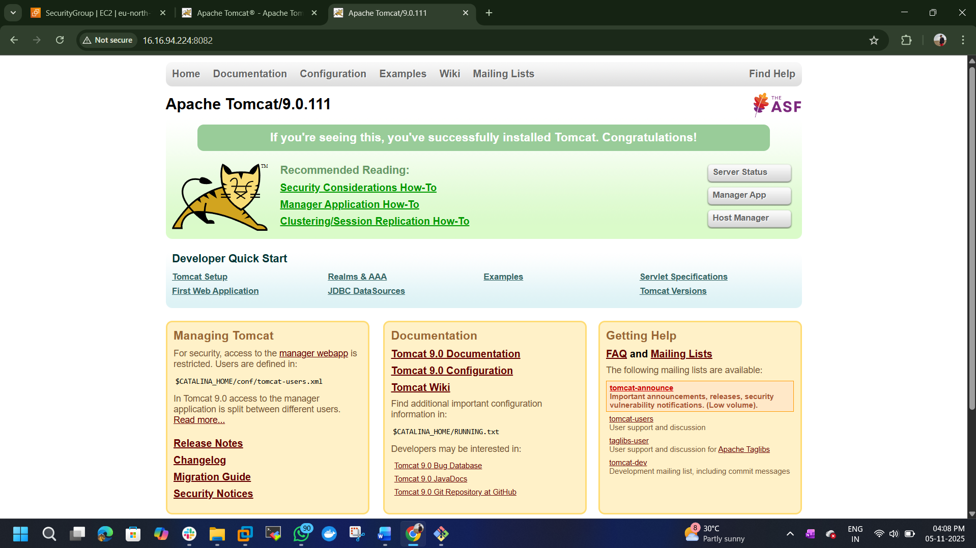

06. Deploy a sample app on webapps
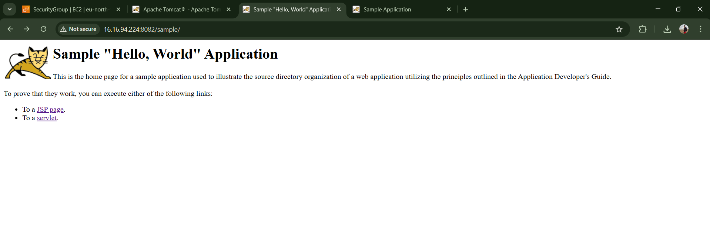
Steps :
Change to webapps directory cd webapps
Get sample file from browser ---- sample.war
wget http://.....
command : ll---- to list sample file

07. Create a tomcat.service file for tomcat.
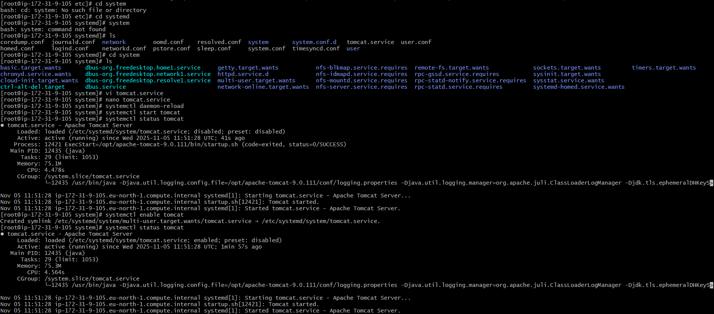
First we need to change directory
Steps :
cd etc
cd systemd
cd system
Then we need to create a service file.
nano tomcat.service
Add the below content to make use systemctl commands
[Unit]
Description=Apache Tomcat Server
After=network.target

[Service]
Type=forking
User=root
ExecStart=/opt/apache-tomcat-9.0.111/bin/startup.sh
ExecStop=/opt/apache-tomcat-9.0.111/bin/shutdown.sh
Restart=always

[Install]
WantedBy=multi-user.target

Then we need to reload and enable the service for that
Commands :
systemctl daemon-reload --- to reload systemd manager configuration
systemctl start tomcat
systemctl enable tomcat
systemctl status tomcat

First we have launch 3 -instance.
Nginx
Apache httpd
HA proxy

Then we need to open those servers in separate terminals

Now we have to connect these 3-servers .
To connect HA proxy to nginx we need to connect with the public ip address
# On nginx terminal ---
cd /etc
cd nginx

08. Configure HA Proxy server.


Steps: first create a haproxy server and allow security credential all traffic.
# copy haproxy public ip and go to nginx-server and paste in #vi /etc/hosts.
#go to apache httpd-server and paste public ip of haproxy #<vi /etc/hosts>

#copy both nginx and httpd public ip and go to haproxy server paste ips in <vi /etc/hosts>
#then install haproxy in proxy server<yum install haproxy>
# <systemctl start haproxy>
#<systemctl enable haproxy>
#<systemctl status haproxy>
#then go to <cd /etc/haproxy/>
# edit file called haproxy.cfg.
#copy both ips of nginx and httpd along with port nuber :81 or :82
#Change the bind from :5000 to 80
To check the status copy haproxy public ip and search in browser.
